R-18.4 Give a complete, weighted graph *G*, such that its edge weights satisfy the triangle

inequality but the MST-based approximation algorithm for TSP does not find an

optimal solution.

Answer:

triangle inequality states that for any triangle, the sum of the lengths of any two sides must be greater than or equal to the length of the remaining side.

Graph

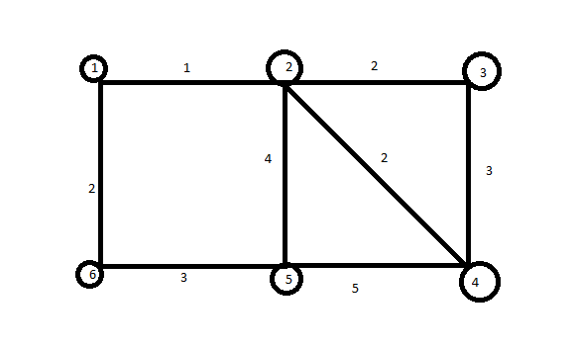

Minimum Spanning Tree:  A spanning treefor a connected graph G is a tree containing all the vertices of G.

MST for the graph is: -

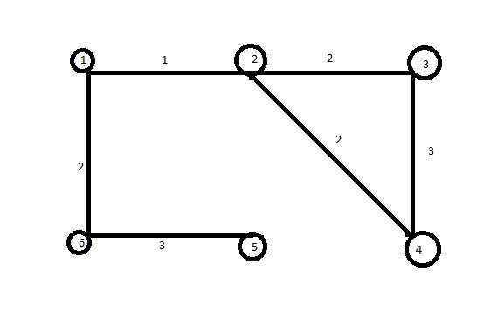

Initial connected weighted graph: -

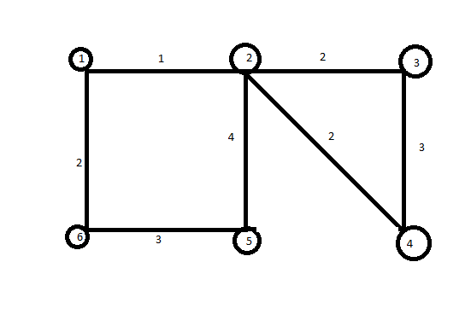

MST is based on travelling sales man find mst first and then next step is to take 4 adding smallest weighted edges to make it a tour.

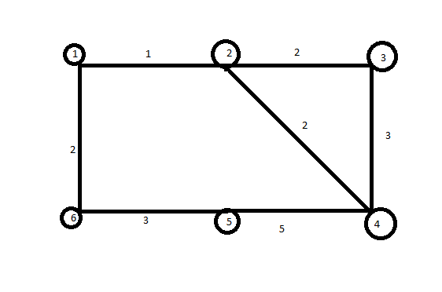

It is not optional TSP Graph: -

Citation:- These graphs were designed in paint.